**Name: Aman Jiddewar.**

**Data Preparation:**

I have corrected the diversification to handle the case of smaller number of investments which skew the diversification factor. This is similar to shrinkage estimator used in IMDB ratings.

$$Corrected Diversification=\frac{v}{(v+m)}*D+\frac{m}{\left(v+m\right)}*C$$

$$Where:$$

$$R=Diversification of firm A to B$$

$$m=Minimum number of investments needed to be considered as significant$$

$$v= Number of investments$$

$C=The mean diversification across the whole set$

The value of m is set to 10 in HW.

**Question 1**.

Part A:

The diversification plot is on corrected diversification which is calculated using method mentioned in data correction part.

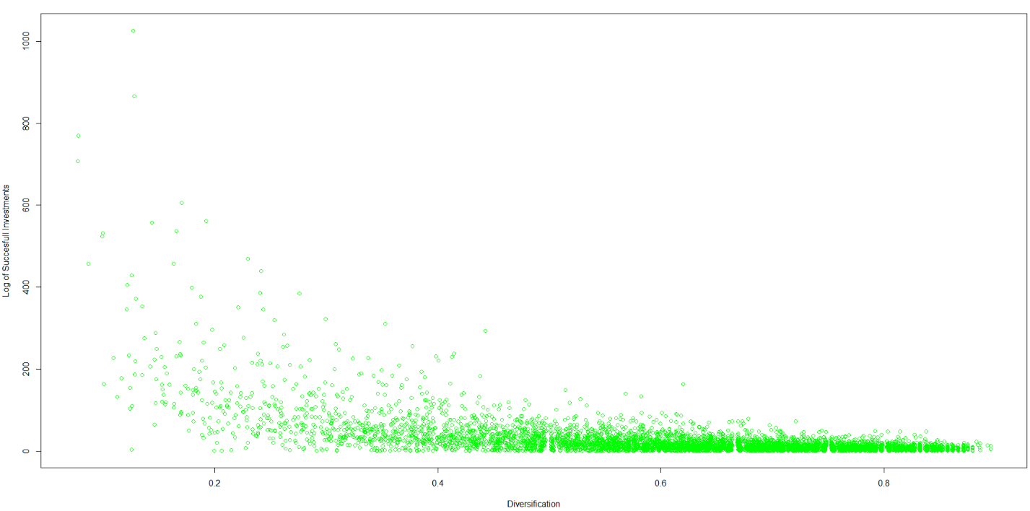

Part B:

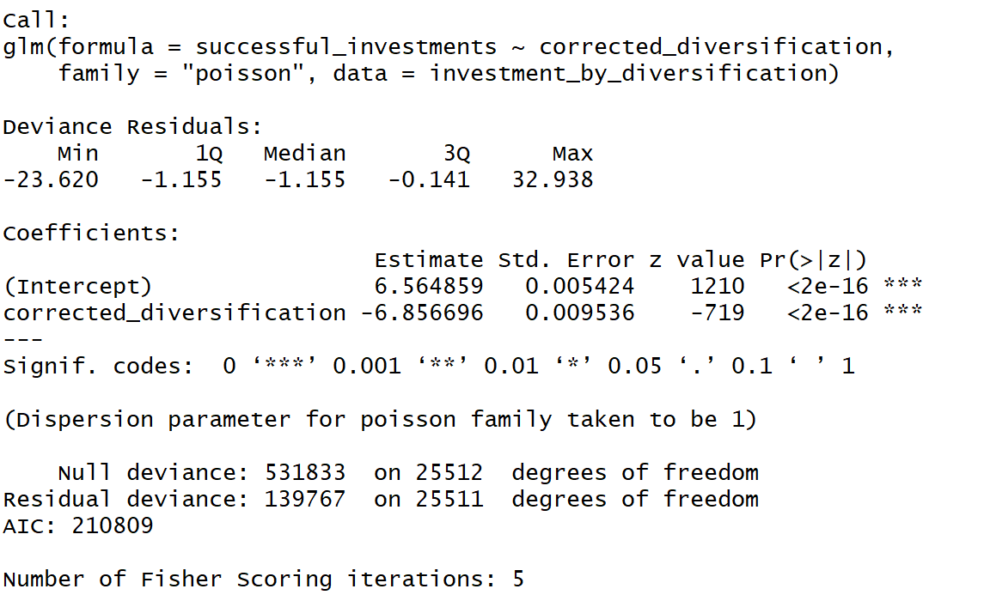

**Question 2**

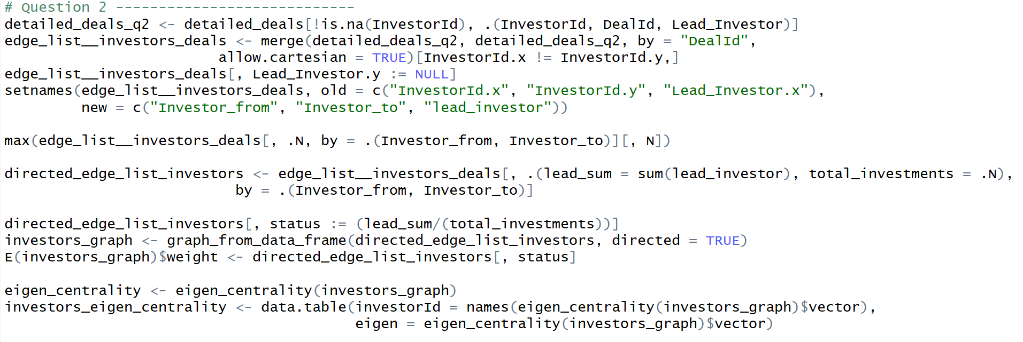

Part A:

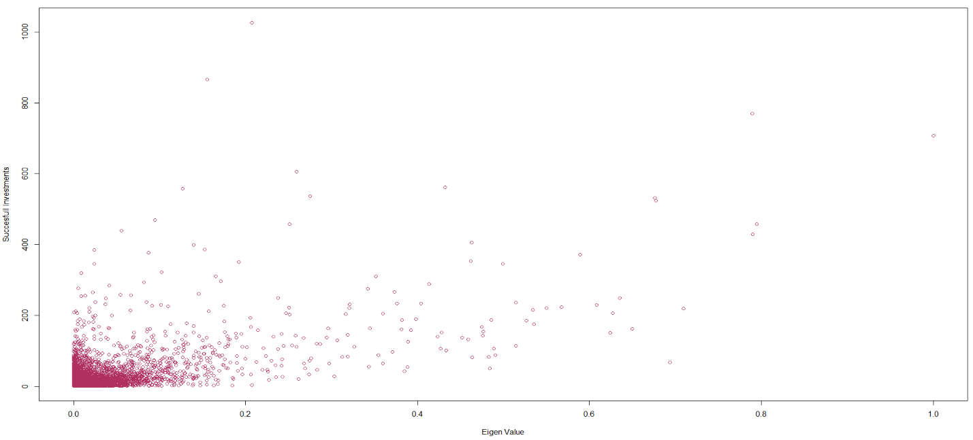

Part B:

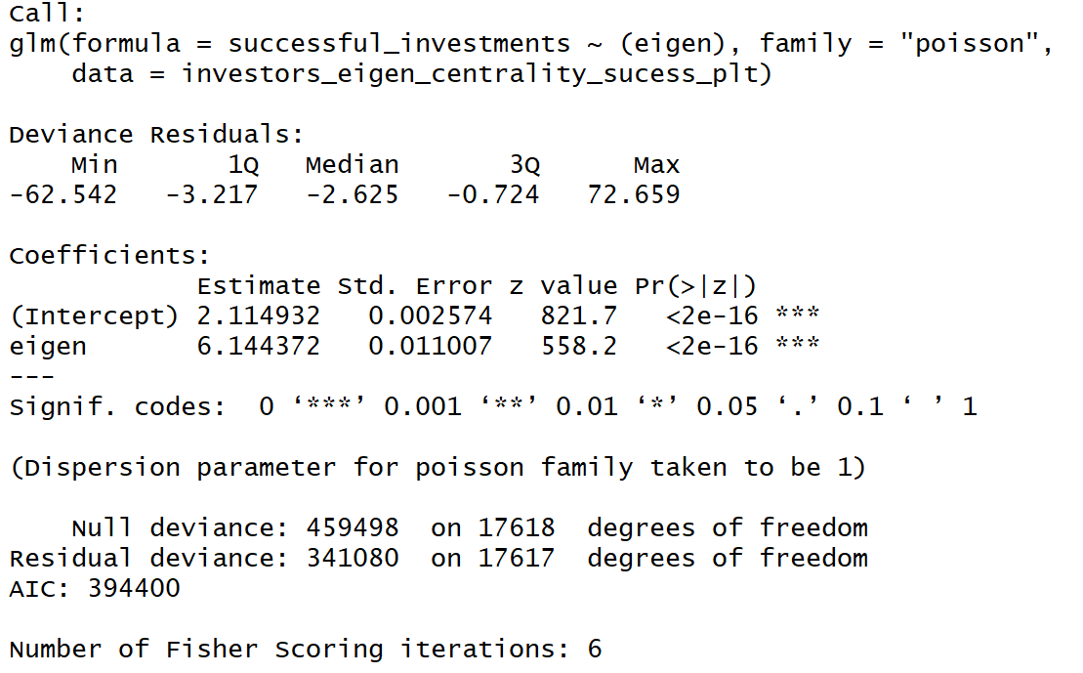

**Question 3**

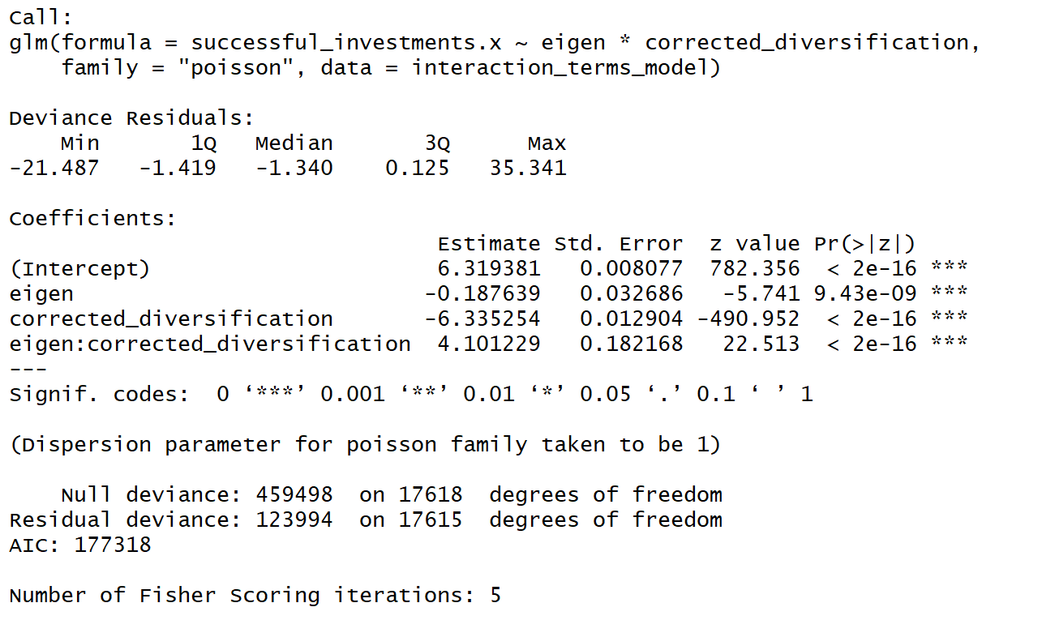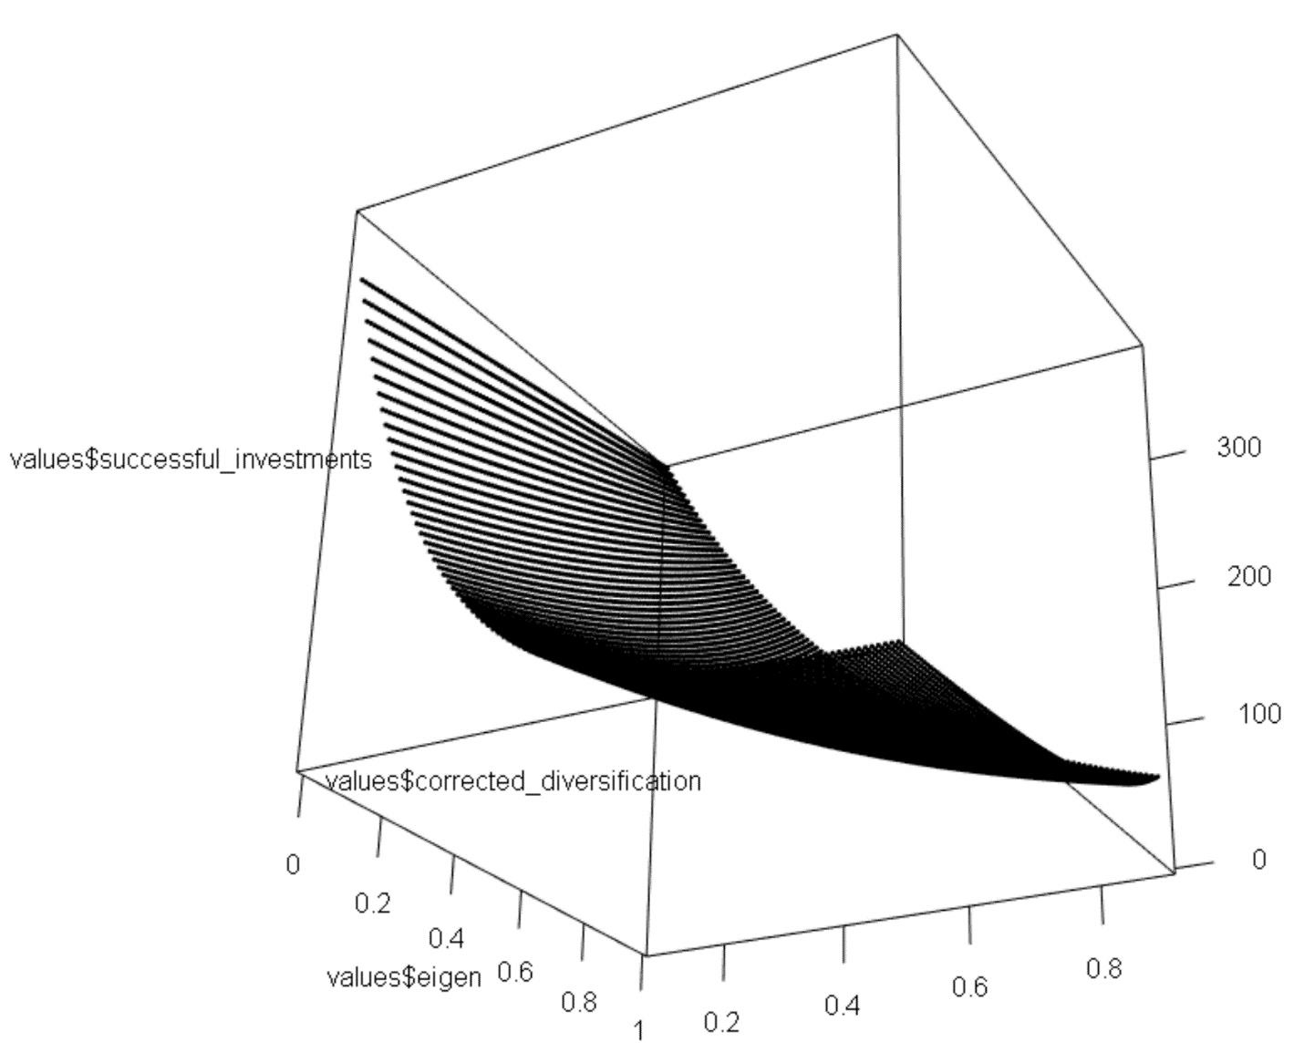

**Question 4:**

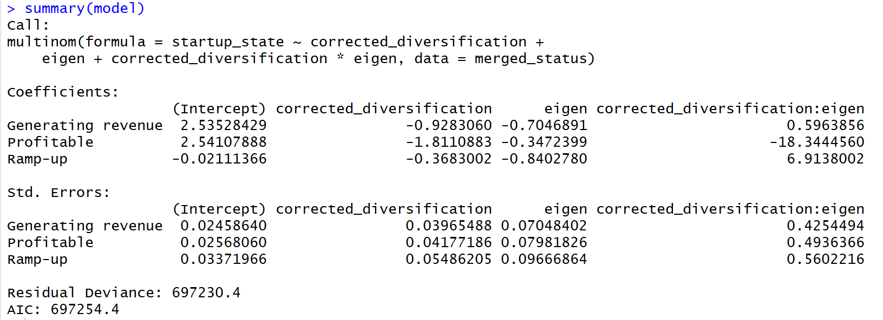

As shown below the values are below 0.05, except for status generating revenue the interaction term is not significant. Over all looking at the model above, diversification has drawback for the start up because it has negative correlation with the state of the startup. This sounds counter-intuitive, because more diversity means more exchange of different ideas.

